A Course Based Project Report on

**DYNAMIC UNIT CONVERTER**

Submitted to the

**Department of Information Technology**

in partial fulfillment of the requirements for the completion of course

DATA VISUALIZATION

BACHELOR OF TECHNOLOGY

IN

**INFORMATION TECHNOLOGY**

Submitted by

B BHARGAVI 23071A1274

CH MOKSHITHA 23071A1278

G SAANVITHA 23071A1285

G SHRESHTA 23081A1289

Under the guidance of

**Mr. P. BalaKesava Reddy**

Assistant Professor, Department of IT, VNRVJIET



**DEPARTMENT OF INFORMATION TECHNOLOGY**

**VALLURUPALLI NAGESWARA RAO VIGNANA JYOTHI INSTITUTE OF ENGINEERING & TECHNOLOGY**

An Autonomous Institute, NAAC Accredited with ‘A++’ Grade, NBA

Vignana Jyothi Nagar, Pragathi Nagar, Nizampet (S.O), Hyderabad – 500 090, TS, India

**DECEMBER 2023**

**VALLURUPALLI NAGESWARA RAO VIGNANA JYOTHI INSTITUTE OF ENGINEERING AND TECHNOLOGY**

An Autonomous Institute, NAAC Accredited with ‘A++’ Grade, NBA Accredited for CE, EEE, ME, ECE, CSE, EIE, IT B. Tech Courses, Approved by AICTE, New Delhi, Affiliated to JNTUH, Recognized as “College with Potential for Excellence” by UGC, ISO 9001:2015 Certified, QS I GUAGE Diamond Rated

Vignana Jyothi Nagar, Pragathi Nagar, Nizampet(SO), Hyderabad-500090, TS, India

**DEPARTMENT OF INFORMATION TECHNOLOGY**



**CERTIFICATE**

This is to certify that the project report entitled “**Dynamic Unit Converter**” is a bonafide work done under our supervision and is being submitted by **B Bhargavi (23071A1274), CH Mokshitha (23071A1278), G Saanvitha (23071A1285),**

**G Shreshta (23071A1289)** in partial fulfilment for the award of the degree of **Bachelor of Technology** in Information Technology, of the VNRVJIET, Hyderabad during the academic year 2023-2024.

**Mr.P.BalaKesava Reddy Dr.D.Srinvasa Rao**

Assistant Professor, IT Associate Professor & HOD, IT

**Course based Projects Reviewer**

**VALLURUPALLI NAGESWARA RAO VIGNANA JYOTHI INSTITUTE OF ENGINEERING AND TECHNOLOGY**

An Autonomous Institute, NAAC Accredited with ‘A++’ Grade,

Vignana Jyothi Nagar, Pragathi Nagar, Nizampet(SO), Hyderabad-500090, TS, India

**DEPARTMENT OF INFORMATION TECHNOLOGY** 

**DECLARATION**

We declare that the course based project work entitled “**Dynamic unit converter**” submitted in the Department of Information Technology, Vallurupalli Nageswara Rao Vignana Jyothi Institute of Engineering and Technology, Hyderabad, in partial fulfilment of the requirement for the award of the degree of **Bachelor of Technology in** **Information Technology** is a bonafide record of our own work carried out under the supervision of **Mr. P. Balakesava Reddy, Assistant Professor, Department of IT, VNRVJIET.** Also, we declare that the matter embodied in this thesis has not been submitted by us in full or in any part thereof for the award of any degree/diploma of any other institution or university previously.

Place: Hyderabad.

|  |  |  |  |
| --- | --- | --- | --- |
| **B. Bhargavi**  (**23071A1274**) | **CH. Mokshitha**  **(23071A1278**) | **G. Saanvitha**  (**23071A1285**) | **G . Shreshta**  (**23071A1289**) |

**ACKNOWLEDGEMENT**

We express our deep sense of gratitude to our beloved President, Sri. D. Suresh Babu, VNR Vignana Jyothi Institute of Engineering & Technology for the valuable guidance and for permitting us to carry out this project.

With immense pleasure, we record our deep sense of gratitude to our beloved Principal, Dr. C.D Naidu, for permitting us to carry out this project.

We express our deep sense of gratitude to our beloved Professor Dr. SRINIVASA RAO DAMMAVALAM, Associate Professor and Head, Department of Information Technology, VNR Vignana Jyothi Institute of Engineering & Technology, Hyderabad-500090 for the valuable guidance and suggestions, keen interest and through encouragement extended throughout the period of project work.

We take immense pleasure to express our deep sense of gratitude to our beloved Guide, **Mr. P. Balakesava Reddy**, Assistant Professor in Information Technology, VNR Vignana Jyothi Institute of Engineering & Technology, Hyderabad, for his/her valuable suggestions and rare insights, for constant source of encouragement and inspiration throughout my project work.

We express our thanks to all those who contributed for the successful completion of our project work.

B BHARGAVI 23071A1274

CH MOKSHITHA 23071A1278

G SAANVITHA 23071A1285

G SHRESHTA 23071A1289

**TABLE OF CONTENTS**

|  |  |  |
| --- | --- | --- |
| S No | Contents | Page No |
| 1. | Abstract | 1 |
| 2. | Introduction | 2 |
| 3. | Source code | 3-6 |
| 4. | Test cases/output | 7-9 |
| 5. | Conclusion | 10 |
| 6. | References | 11 |

**ABSTRACT**

A unit conversion expresses the same property as a different unit of measurement. For instance, time can be expressed in minutes instead of hours, while distance can be converted from miles to kilometers, or feet, or any other measure of length.Excel's "CONVERT" function is a powerful tool that enables you to perform real-time unit conversions, saving you time and effort. This Excel Unit Converter automates the process, eliminating the need for complicated manual calculations. It's simple. Just enter the measurement you want to convert, specify the original unit of measurement and the unit of measurement you want to convert to, and the "CONVERT" formula will take care of the rest. Plus, the advantage of this Unit Converter is that you can access it from any device, allowing you to have your Excel files with this tool anywhere and anytime.

**INTRODUCTION**

* 1. **PROBLEM DEFINITION**

This Excel Unit Converter is an efficient tool that allows you to perform unit conversions quickly and accurately in your Excel spreadsheets. Created in MS Excel, this resource allows you to easily convert between different units of measurement, such as meters, gallons, light years, and pascals, using the powerful "CONVERT" formula.

* 1. **OBJECTIVE**

It's simple. Just enter the measurement you want to convert, specify the original unit of measurement and the unit of measurement you want to convert to, and the "CONVERT" formula will take care of the rest. Plus, the advantage of this Unit Converter is that you can access it from any device, allowing you to have your Excel files with this tool anywhere and anytime.

Unit Converter for Excel is an adding for the Microsoft Excel to perform various conversions between many types of measurement units. The units are grouped in the following categories: Dimensions and capacity, Energy and power, Mechanics, Hydraulics, Heat, Electricity, Magnetism, Light and sound, Radiation. The online unit converter allows accurately, quickly, and for free convert common units of measurement. Enter your value in the input box and select from.

**2. SOURCE CODE**

# CREATE AND FORMAT TABLES:

1. Select a cell within your data.
2. Select **Home**> **Format as Table.**
3. Choose a style for your table.
4. In the **Create Table** dialog box, set your cell range.
5. Mark if your table has headers.
6. Select **OK**.

**DEFINING NAME OF LISTS:**

In Excel, you can define names for lists to make it easier to reference and work with specific ranges of cells. Here's how you can define names for lists:

1. Using the Name Box
2. Select the Range:
3. Select the range of cells that you want to name.
4. Go to the Name Box:
5. The Name Box is located to the left of the formula bar. Click on the dropdown arrow in the Name Box.
6. Enter a Name:
7. Type the desired name for your list and press Enter.

**DATA VALIDATION:**

Data validation in the context of spreadsheets, such as Microsoft Excel, refers to the process of setting rules or criteria to control the type and format of data that can be entered into a cell or range of cells. This helps ensure that the data in your spreadsheet is accurate, consistent, and meets specific requirements. Data validation is commonly used to prevent errors, enforce data integrity, and make data entry more efficient.

The settings tab is where you enter the validation criteria. There are eight options available to validate for user input:

* Any Value - It removes any existing data validation.
* Whole Number - It allows only whole numbers. For example, you can specify that the user must enter the number between 0 to 30.
* Decimal - The user must enter a number with decimal values.
* List - The user will have to create a drop-down list to choose from.
* Date - The user will have to enter the date format.
* Time - The user should enter a time.
* Text Length - It validates input based on the length of the data.
* Custom - It validates the user input using a custom formula.

Basic steps for data validation:

1. Select the Cell or Range:
2. Click on the cell or select the range of cells where you want to apply data validation.
3. Go to the Data Tab:
4. Navigate to the "Data" tab on the Excel ribbon.
5. Click on Data Validation:
6. In the "Data Tools" group, click on "Data Validation."
7. Choose Validation Criteria:
8. In the "Data Validation" dialog box, go to the "Settings" tab.
9. Choose the type of data validation you want. Common criteria include whole numbers, decimals, dates, times, text length, custom formulas, and more.
10. Configure Validation Settings:
11. Depending on the chosen criteria, configure additional settings such as minimum and maximum values, allowed dates, or custom formulas.

**DROP-DOWN LIST:**

A drop-down list, also known as a dropdown menu or combo box, is a user interface control that allows users to select one item from a predefined list of options.If you want to create a dependent drop-down list in Excel, where the options in one drop-down list depend on the selection made in another drop-down list, you can use a combination of named ranges and data validation.

Set Up Data Validation for the Main Category

1. Select the Cell for the Main Category:
2. Select the cell where you want the main category drop-down.
3. Go to Data Validation:
4. Go to the "Data" tab, click on "Data Validation."
5. Choose List as Criteria:
6. In the "Data Validation" dialog box, choose "List" as the criteria.
7. In the "Source" field, enter =Categories.

**VLOOKUP**:

The VLOOKUP function in Excel is a powerful tool for searching and retrieving data from a table. It stands for "Vertical Lookup" and is commonly used when you have a table of data and want to find a specific value in the leftmost column of that table.

Syntax:=VLOOKUP(lookup_value,table_array,col_index_number,[range_lookup])

**INDIRECT:**

The INDIRECT function in Excel is used to indirectly reference a cell or range of cells. It takes a text string argument that specifies the cell or range reference. The contents of the referenced cell or range are then returned or used as the reference for another function.

Syntax:=INDIRECT(ref_text,[a1])

**CONVERT:**

To convert data from one unit or format to another in Excel, there are various functions you can use depending on your specific conversion needs.

Syntax:=CONVERT(number,from_unit,to_unit)

**IFERROR:**

IFERROR function to trap and handle errors in a formula. IFERROR returns a value you specify if a formula evaluates to an error.

Syntax: =IFERROR(value,value_if_error)

**MACRON:**

Macros are a set or sequence of instructions that perform as and when required by the user. Initially, a macro is to be recorded. Then the macro is being executed in order to perform a set of a predefined set of commands in Microsoft Excel. Macros save a huge amount of time in performing a set of repetitive actions.

**3. TEST CASES/ OUTPUT**

* 1. **Test case:1**

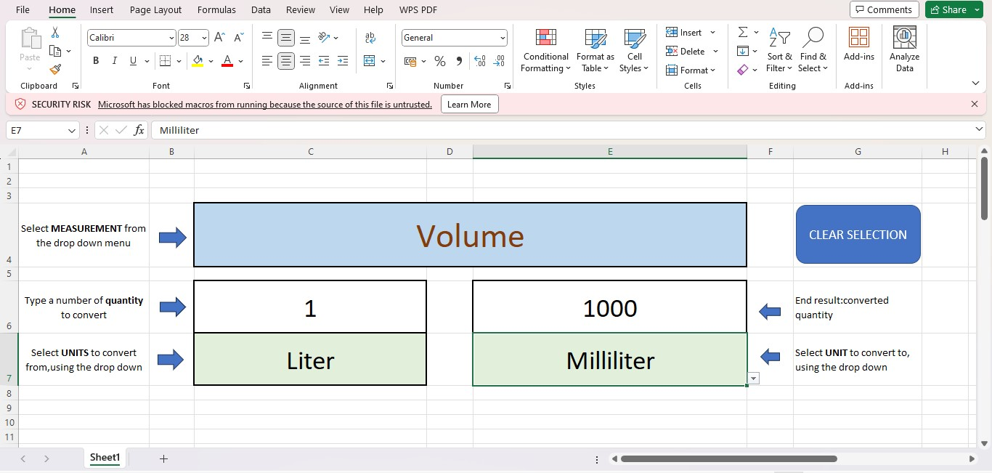

**3.2 Test case : 2**

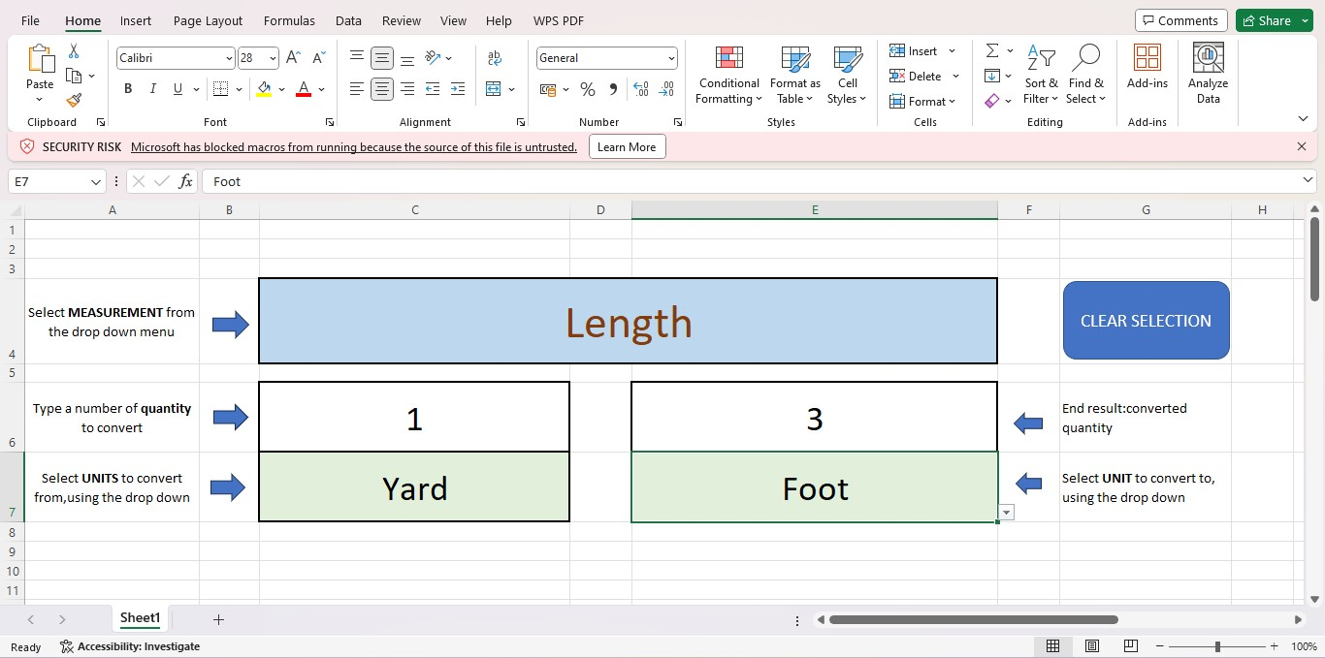

**3.3 Test case :3**

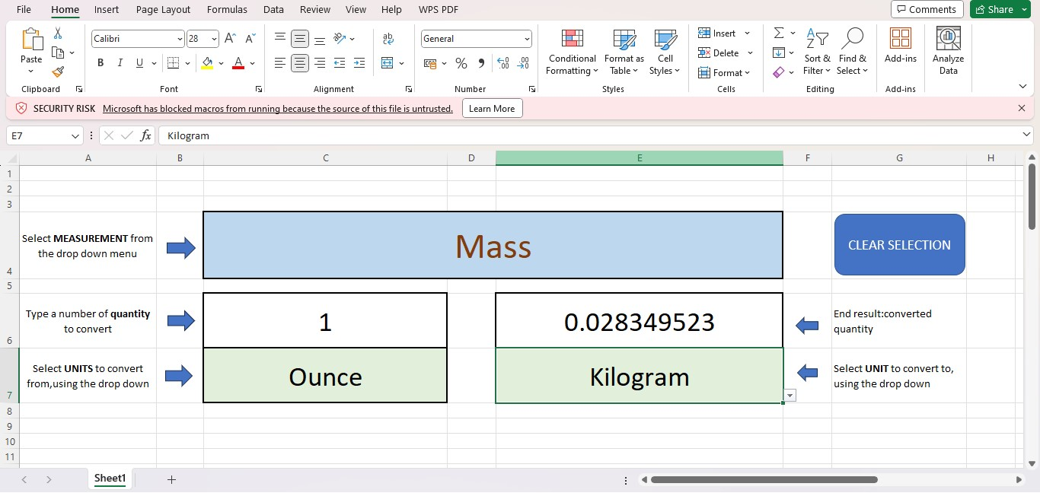

**3.4 Test case:4**

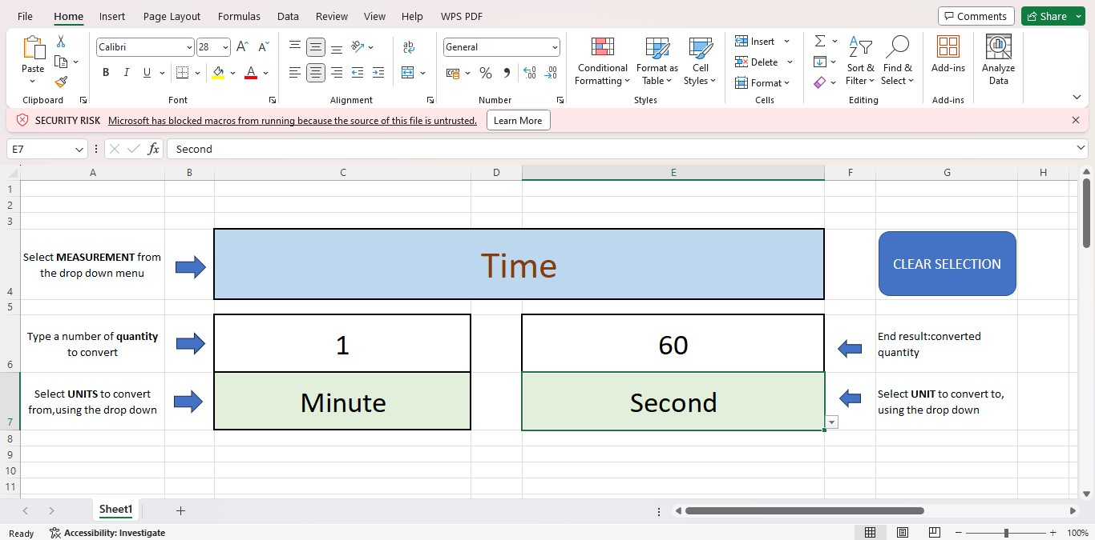

**CONCLUSION**

The unit converter project in Excel provides a user-friendly and efficient tool for converting various units across different metrics. Its intuitive design and accurate calculations make it a valuable resource for simplifying complex conversions. By utilizing Excel's functionalities, this project not only meets the diverse needs of users but also showcases the versatility of spreadsheet applications in practical applications.. By creating a user-friendly interface that allows users to seamlessly convert between different units, the converter simplifies complex calculations and promotes a more streamlined workflow. Its dynamic nature ensures adaptability to various scenarios and requirements, providing users with the flexibility they need. Whether dealing with length, weight, volume, or any other unit, this Excel-based converter not only saves time but also reduces the likelihood of errors, contributing to a more reliable and productive data analysis process. As we conclude our exploration of the dynamic unit converter, it becomes evident that this Excel tool is a valuable asset for anyone working with multiple units, offering a user-friendly solution to the intricate challenges of unit conversion.

**REFERENCES**

1. [**https://corporatefinanceinstitute.com/resources/excel/iferror-function/**](https://corporatefinanceinstitute.com/resources/excel/iferror-function/)
2. [**https://support.microsoft.com/en-au/office/iferror-function-c526fd07-caeb-47b8-8bb6-63f3e417f611**](https://support.microsoft.com/en-au/office/iferror-function-c526fd07-caeb-47b8-8bb6-63f3e417f611)
3. [**https://youtu.be/knO0-YTd4BQ?si=sj9DaZsl4KjNCiF7**](https://youtu.be/knO0-YTd4BQ?si=sj9DaZsl4KjNCiF7)